

**School of Computing**

**SRM IST, Kattankulathur – 603 203**

**Course Code: 18CSC206J**

**Course Name: Software Engineering and Project Management**

|  |  |
| --- | --- |
| **Experiment No** | 12 |
| **Title of Experiment** | Provide the details of Architecture Design/Framework/ Implementation |
| **Name of the candidate** | Shaurya Singh Srinet |
| **Team Members** | Shounak Chandra, Parth Galhotra |
| **Register Number** | RA2111032010006, RA2111032010026, RA2111032010029 |
| **Date of Experiment** | 13.4.23 |

**Mark Split Up**

|  |  |  |  |
| --- | --- | --- | --- |
| **S. No** | **Description** | **Maximum Mark** | **Mark Obtained** |
| 1 | Exercise | 5 |  |
| 2 | Viva | 5 |  |
| **Total** | | **10** |  |

**Staff Signature with date**

**Aim:**

To provide the details of architectural design/framework/implementation

**Team Members:**

|  |  |  |  |
| --- | --- | --- | --- |
| **S No** | **Register No** | **Name** | **Role** |
| **1** | **RA2111032010006** | **Shaurya Singh Srinet** | **Representative** |
| **2** | **RA2111032010026** | **Shounak Chandra** | **Member** |
| **3** | **RA2111032010029** | **Parth Galhotra** | **Member** |

**Architectural Design:**

1. Dashboard(Home) Design

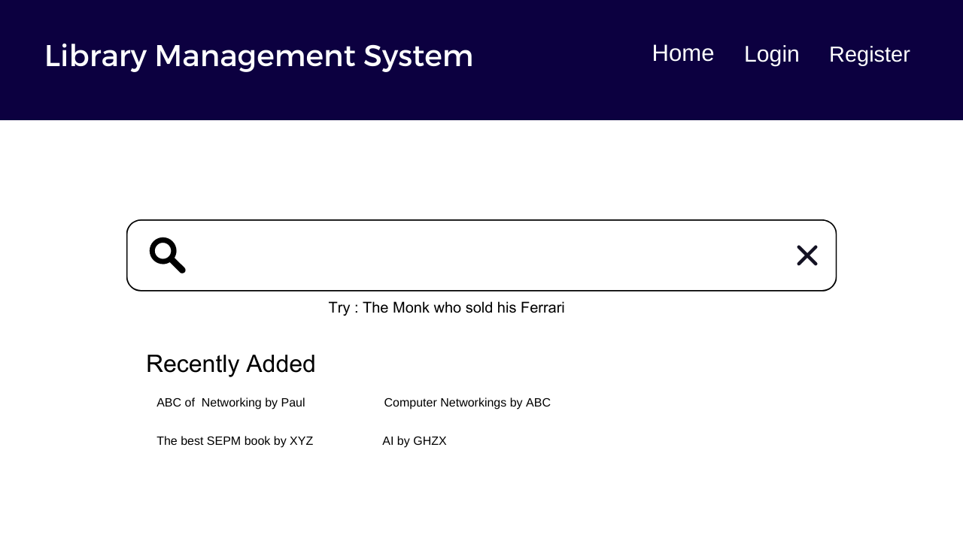

1. Managing Book List Design

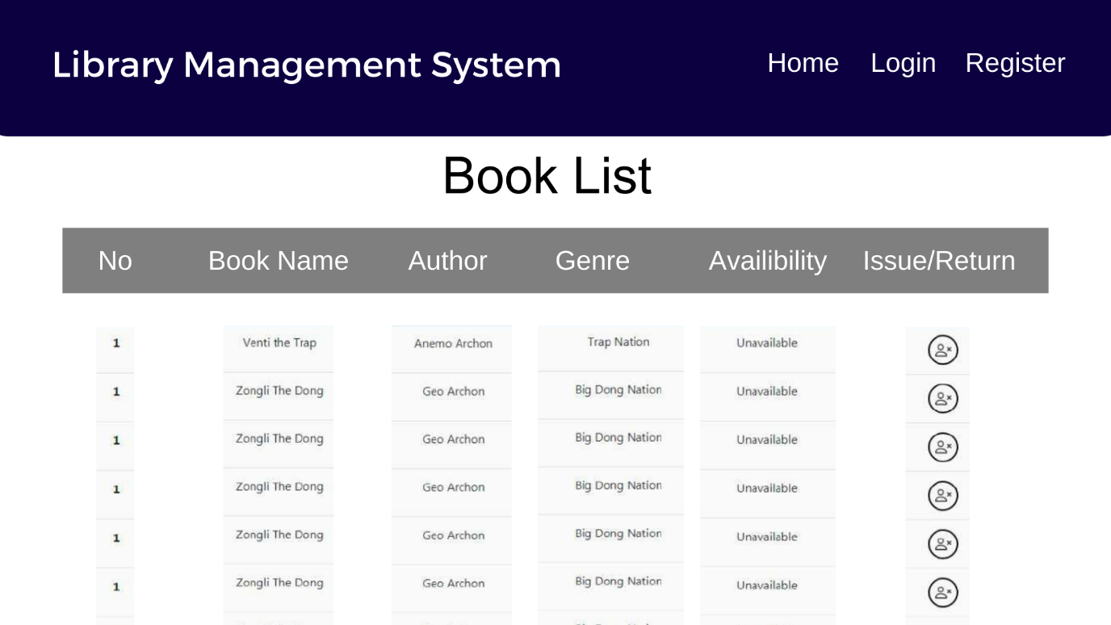

1. Issuing/Returning a Book Design

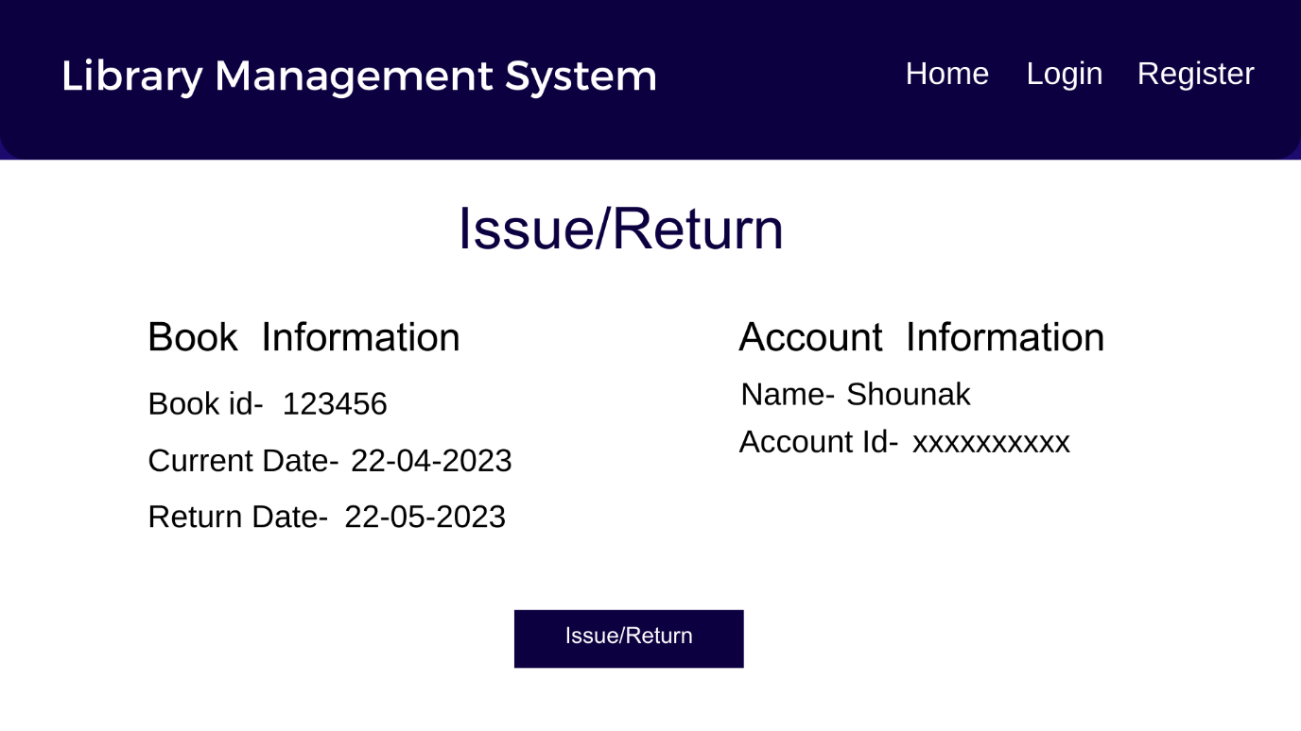

**Result:**

Thus, the details of architectural design/framework/implementation along with the screenshots were provided.